***MySQL Database***

Library Database:

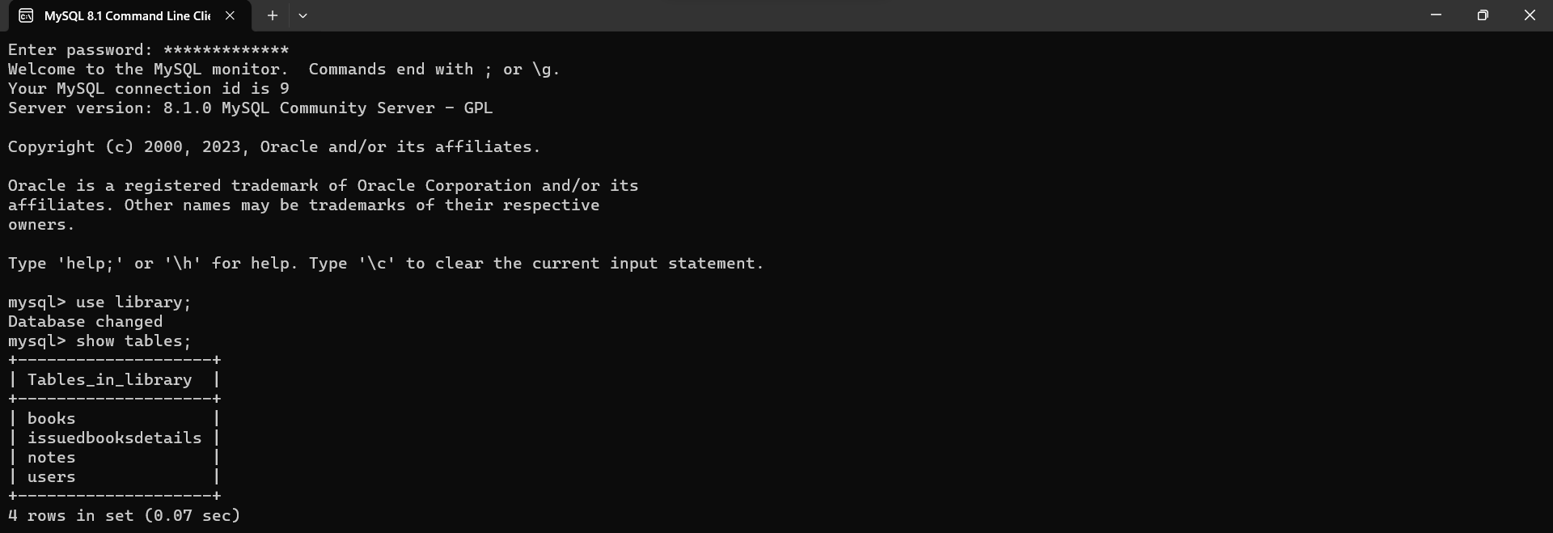

Books Table:

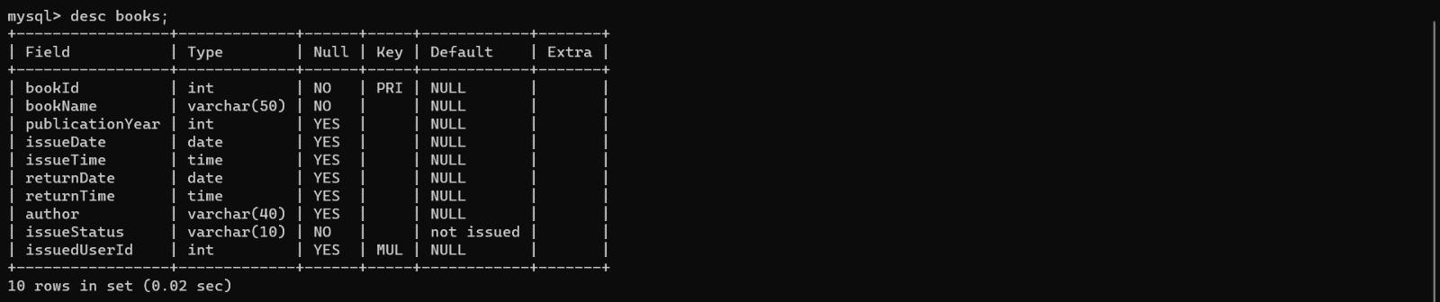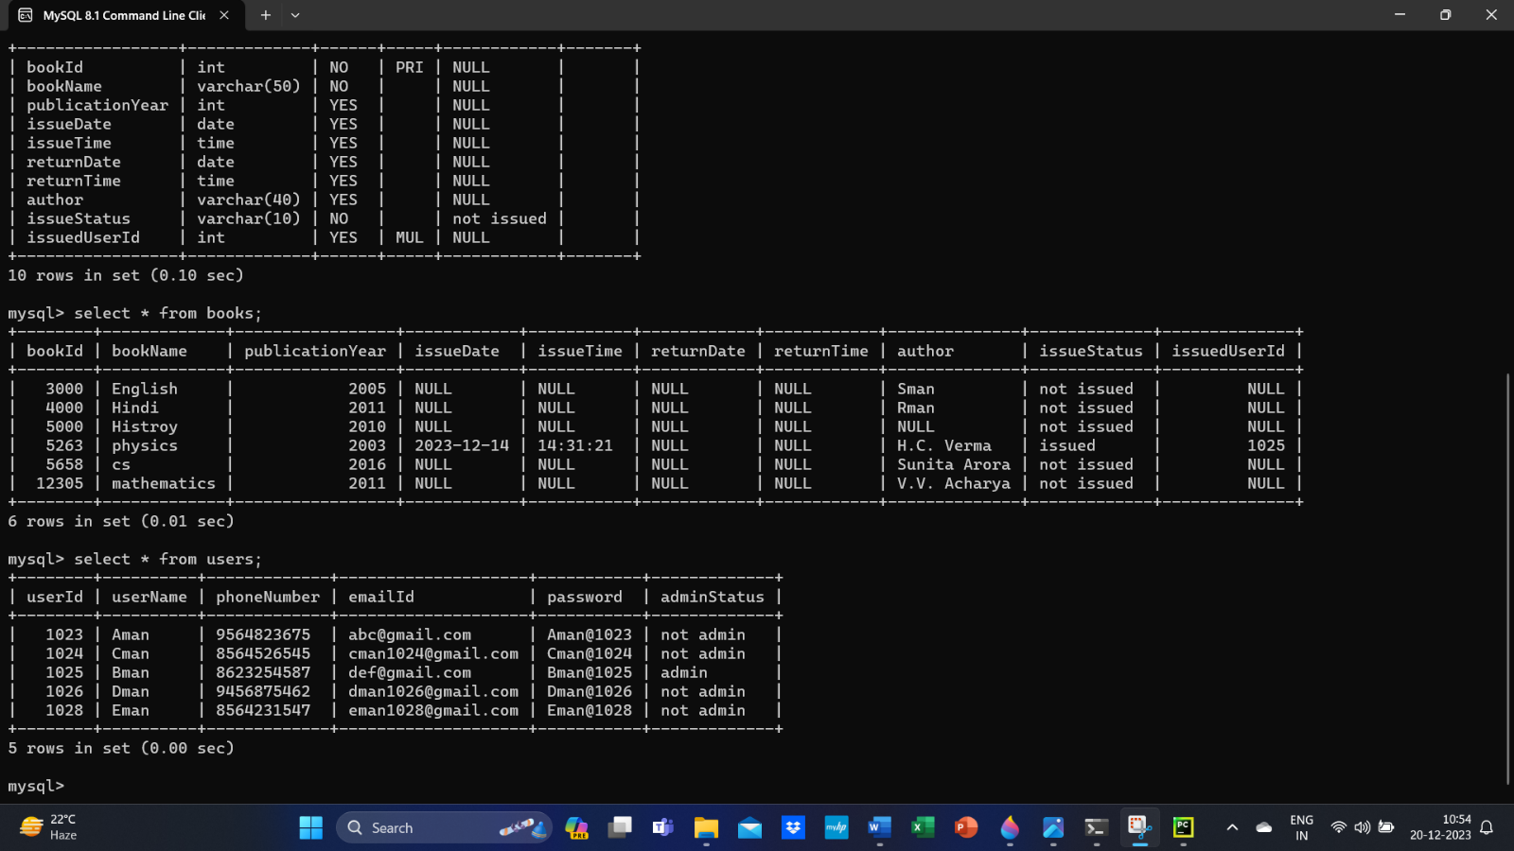

Users Table:

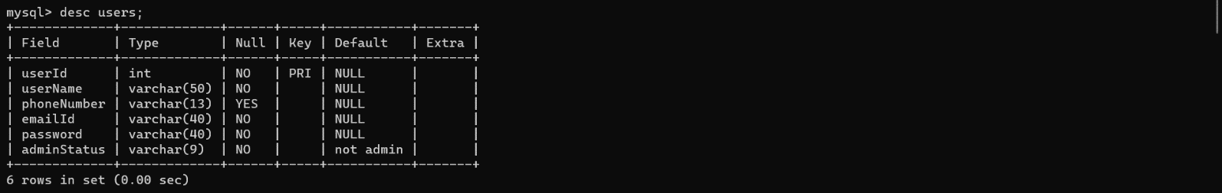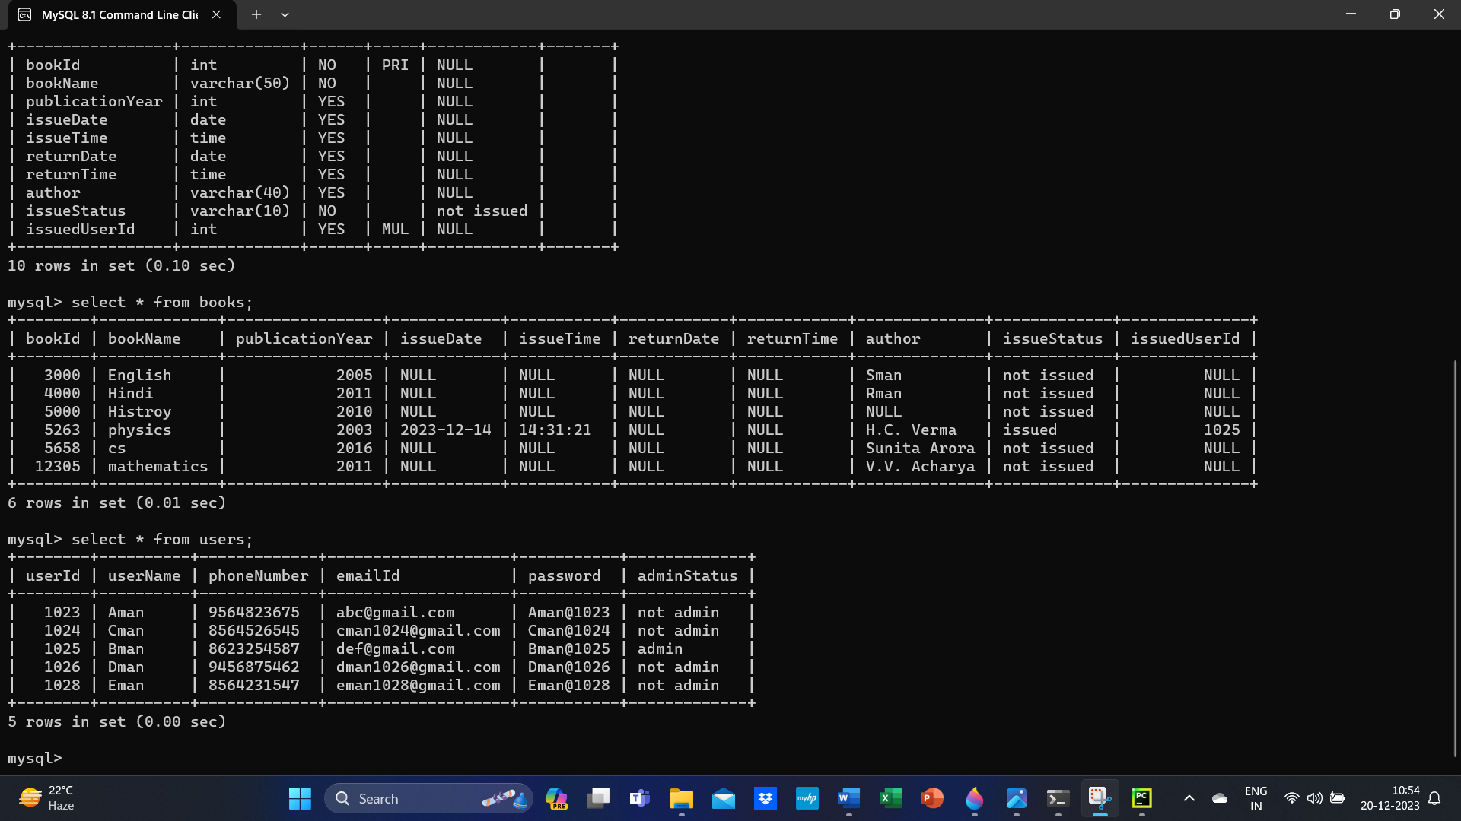

Notes Table:

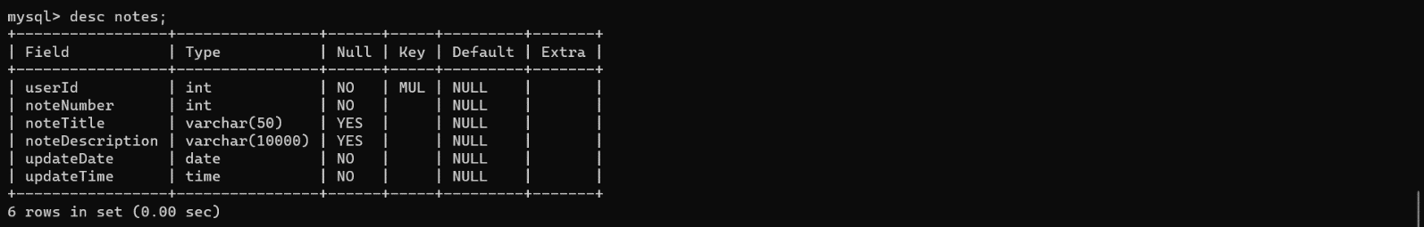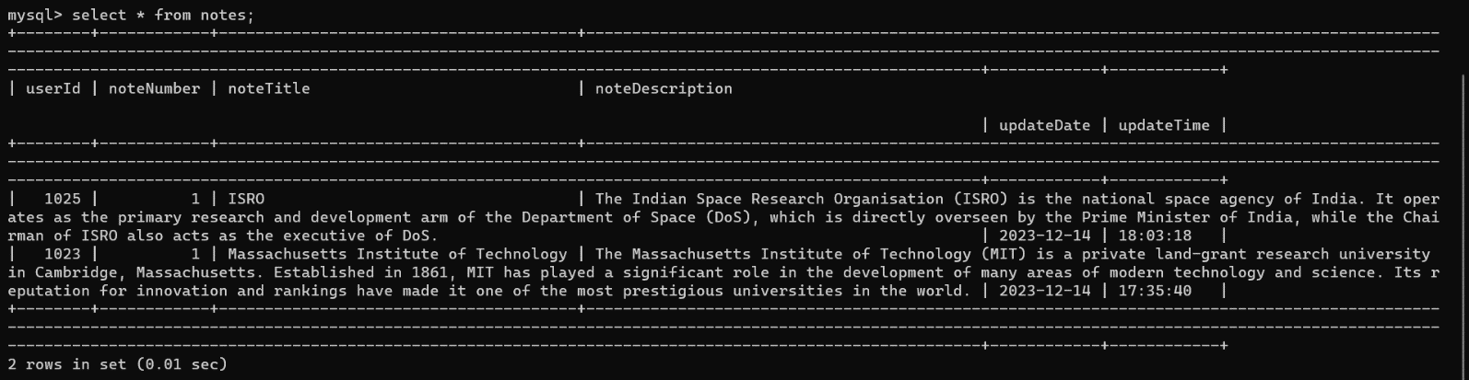

Issued Books Details Table:

